## ****Sales Performance Ad-hoc Analysis Report****

**Analyst:** Saurav Negi  
**Date:** 07/08/2025

### ****1. Executive Summary****

This report provides an ad-hoc analysis of sales performance across product categories and regions for the given period. The focus is on identifying trends, revenue changes, and regions/products most impacted by performance dips.  
Key findings highlight significant revenue and unit sales declines in **Electronics** and **Clothing** categories, with the **East** region being the most affected from **November to December**.

### ****2. Data Overview****

* **Source:** Internal Sales Dataset
* **Period Covered:**01/10/2024 – 31/12/2024
* **Rows:** 7,360
* **Columns:** 6
* **Key Fields:**
  + Date – Transaction date
  + Region – Sales region
  + Product – Product category
  + Revenue – Sales revenue in USD
  + Units Sold – Number of units sold
  + SKU- Stock Keeping Unit

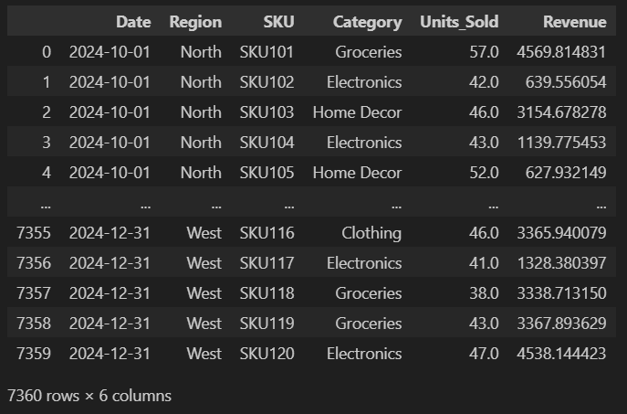

### ****3. Methodology****

1. **Data Cleaning**
   * Checked for missing values using df.isnull().sum()
   * Checked for duplicate rows and found no duplicates
2. **Exploratory Data Analysis (EDA)**
   * Grouped and aggregated data by time periods, products, and regions

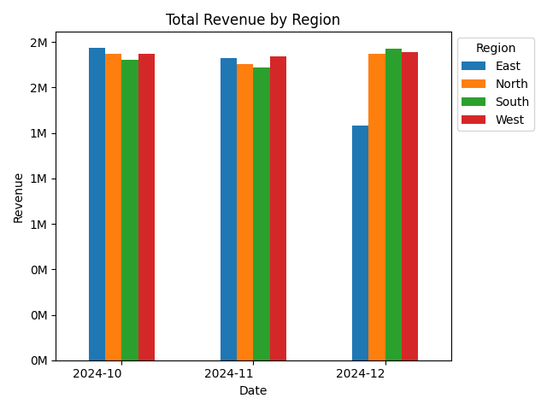

* + Analyzed trends using line and bar charts

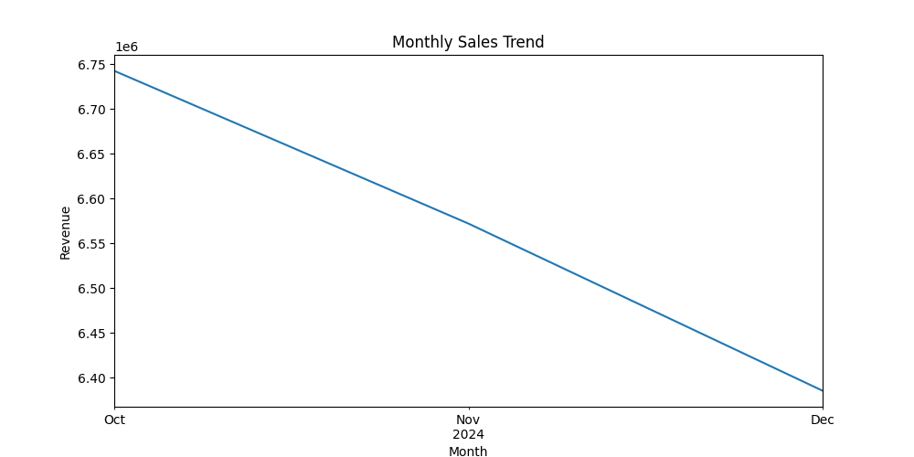

1. **Filtering & Drill-Down**
   * Narrowed focus to Electronics and Clothing after identifying significant dips

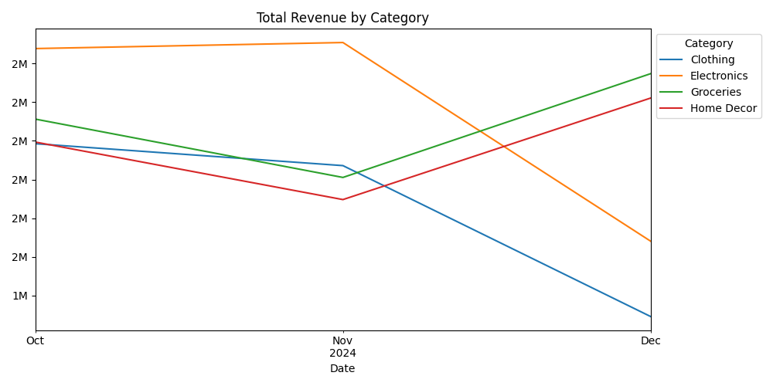

* + Isolated the East region for impact assessment

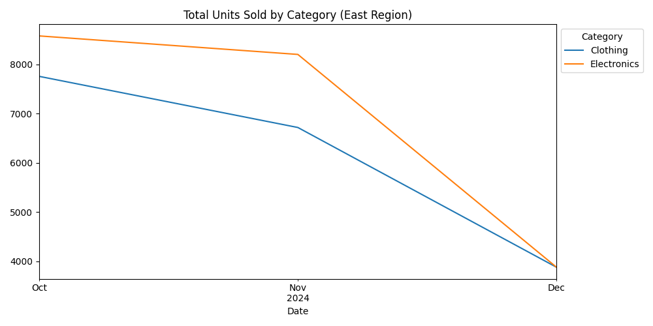

1. **Visualization Tools**
   * Python (Pandas, Matplotlib)
   * Charts generated for monthly trends and region-wise performance

### ****4. Key Findings****

* **Overall Trends**
  + Sharp decline in Electronics and Clothing revenue and units sold in December
* **Regional Impact**
  + East region experienced the largest decline for the affected products
  + Other regions showed smaller or negligible drops
* **Possible Factors** (hypothetical since external data not available)
  + Seasonal demand shift
  + Stock or supply chain issues
  + Competitive market changes

### ****6. Recommendations****

* Investigate supply chain and distribution issues in the East region.
* Conduct customer feedback surveys for Electronics and Clothing.
* Monitor January–March data to check if the decline continues.
* Plan targeted promotions or stock adjustments for East region.

### ****7. Conclusion****

The ad-hoc analysis successfully identified the products and region most affected by performance drops. The East region’s Electronics and Clothing categories require immediate attention. Further data from the upcoming months will help validate the cause and refine the strategy.